MATRIX CHAIN MULTIPLICATION
Code:
#include <stdio.h>
#include <limits.h>

int min(int a, int b)
{
return (a < b) ? a : b;
}

int main()
{
int n, amount;

printf("Enter number of denominations: ");
scanf("%d", &n);

int coins[n];

printf("Enter coin denominations:\n");
for (int i = 0; i < n; i++)
{
scanf("%d", &coins[i]);
}

printf("Enter amount: ");
scanf("%d", &amount);

int dp[amount + 1];

dp[0] = 0;

// Initialize DP array
for (int i = 1; i <= amount; i++)
{
dp[i] = INT_MAX;
}

// Dynamic Programming
for (int i = 1; i <= amount; i++)
{
for (int j = 0; j < n; j++)
{
if (coins[j] <= i && dp[i - coins[j]] != INT_MAX)
{
dp[i] = min(dp[i], dp[i - coins[j]] + 1);
}
}
}

if (dp[amount] == INT_MAX)
printf("Amount cannot be made using given coins.\n");
else
printf("Minimum number of coins = %d\n", dp[amount]);

return 0;
}

OUTPUT:
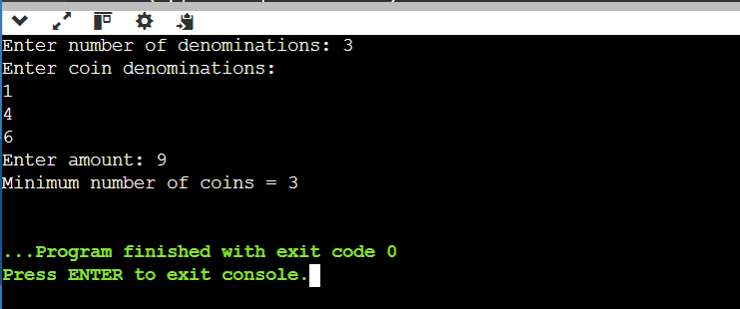

Conclusion:
Complexity | Value
Time Complexity | O(N × M)
Space Complexity | O(N)

